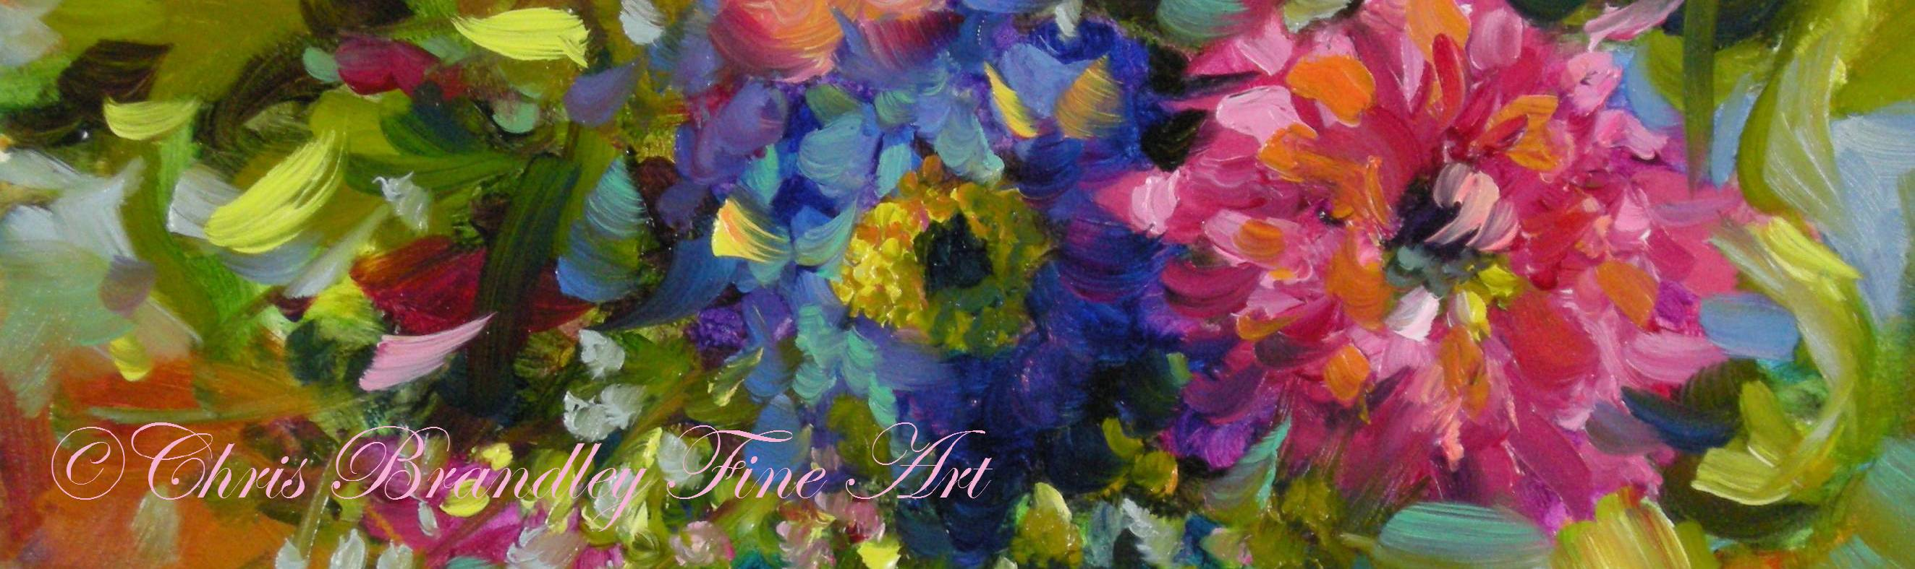

Supply List

The brands and colors listed are what I use to achieve my style of paintings.
(**I’ve created a 2nd list of oils at the bottom of this page for the budget-
minded. It lists colors that can be used to replace the premium brands.
You might already have paints not on this list that may work, so please
don’t hesitate to contact me if you have any questions!
I order my paints from Dick Blick. I have compiled a list paints there to
Make it easier for you! Just click on the link.

- Oil Paints (Premium List):
- Titanium White (Winsor and Newton)
- Richeson Shiva Ice Blue
- Sap Green (Rembrandt)
- Caribbean Blue (Old Holland Oils)
- Ultramarine Blue deep (or French Ultramarine) (Rembrandt)
- Winsor Violet (aka Dioxazine) (Winsor and Newton)
- Transparent Oxide Brown (Rembrandt)
- Transparent Oxide Orange (Rembrandt)
- Magenta (Winsor and Newton)
- Permanent Rose (Winsor and Newton)

- Transparent Red Medium (Rembrandt)
- Cadmium Orange (Rembrandt)
- Cadmium Yellow medium (Rembrandt)
- Cadmium Yellow Lemon (Rembrandt)
- Indian Yellow (Winsor and Newton only)
(Extra Optional Colors):
- Pthalo Green yellow (Rembrandt)
- Alizarin Crimson (Winsor and Newton)
- Cadmium Yellow Deep
- Naples Yellow Light (Sennelier)
- Fluor Pink (Master’s Touch) – (Hobby Lobby)

- Medium and Solvent:
- You will need medium to thin your oil paints. I use a half and half
mix that combines one part Refined Linseed Oil and one part Solvent.
- Solvent choices: Gamsol (by Gamblin); or Turpenoid (by Weber).
**(Please bring ODORLESS solvent!)**

- Two small jars with lids; one for the solvent, and
one for the medium mix. (I like the Mona Lisa
Cleaning tank for my solvent.)

- Brushes: Brushes are a personal choice and sometimes it takes trying a few
out before finding the right “fit”! My current favorites are the Winsor &
Newton Monarch flat, size 14, and size 10.
Another Option: Royal & Langnickel Sizes ¾ flat; 12 flat
and 2 flat.
I also occasionally use Master’s Touch size 2 flat shader (Hobby Lobby)
and a small liner or round size 0. Bring some extras you like working
with as well.

- Kemper Wipe Out Tool

- Palette Knife
- Table top easel OR portable light weight floor easel.

- Palette (at least 12x16”). I use a 12x16 glass (from a frame)
with taped edges. I place it over gray paper inside my palette
box). *Disposable paper palettes work fine, as well.
**Pizza boxes make great carriers for wet paintings!

- Palette Box with lid to keep paint from drying out (OPTIONAL but
recommended).

- Painting Surfaces: Ampersand Gessobord is my preferred
Painting suface; however, canvas is welcome. (The result will be
slightly different). You will need the following sizes:
- 8x10 (at least 2)
- 8x10, 9x12 or 11x14 (for student choice painting…pick one)
- Bring extras just in case.
- Reference photos: Bring at least 2 to choose from. (this
Can be printed out or on a laptop, ipad or other device). Ideas
Include windows and flower boxes, landscape, pet, butterfly, fruit
etc.
*I will supply the photo for the demo portion of the workshop.
- Notebook and pen
- Paper towels: Viva brand or blue shop towels. *the brand
really does make a difference!
- Trash bag
- Disposable latex or vinyl gloves (OPTIONAL)

(The next page is the supply list for the budget-minded that can be used
to replace the premium oils.)

**Budget List of Oils: (to replace premium oils list)
*Winton is the student grade of Winsor & Newton Oils
- Titanium White (Winton)
- Ice Blue (Richeson Shiva Brand)
- Sap Green (Winton)
- Pthalo Turquoise (replaces Caribbean blue) (Winsor & Newton Artist colors)
- French Ultramarine Blue (Winton)
- Winsor Violet (aka Dioxazine) (Winton)
- Transparent Oxide Brown (Rembrandt)
- Transparent Red Medium (Rembrandt)
- Burnt Sienna (Replaces Transparent Oxide Orange) (Winton)
- Magenta (Winton)
- Permanent Rose (Winton)
- Cadmium Orange Hue (Winton)
- Lemon Hue (Winton)
- Cadmium Yellow Hue (Winton)
- Indian Yellow (Winsor & Newton Artist color ONLY)

